Gabi High School

COM432E - Design Techniques for Website Report

Gabi High School Design Report

COM/15/17

Derrick Mbarani

Table of Contents

**sitemap1**

**wireframes2**

home page3

clubs and societies4

testimonials card5

gallery6

home page layout7

**typography8**

**colors9**

**layout10**

**texture10**

# Sitemap

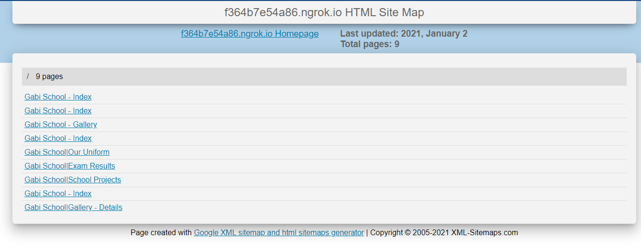

Human readable HTML sitemap as well as an XML sitemap is available on the project folder.

# Wireframes

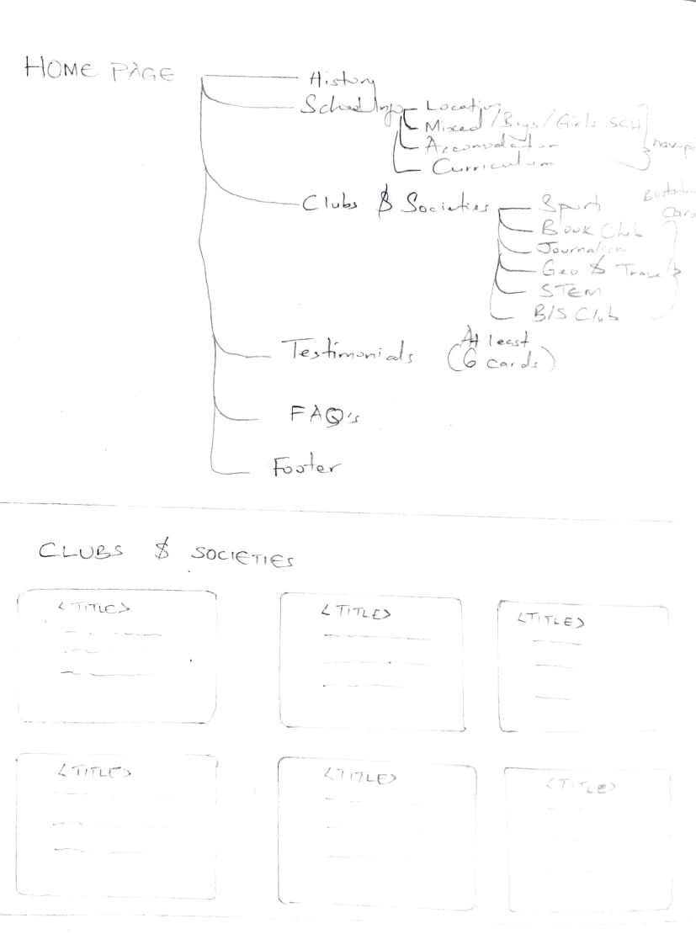

# 

# 

# A better view can be made from: https://www.figma.com/file/EzDa3XuMbpfPB2RsQ3FTCS/high-school-system?node-id=0%3A1

# Typography

Poppins, one of the more popular sans-serif fonts on the web with a smoother edge giving an easier feel to the text. Makes text more readable and easier to the eyes.

Raleway is a sans serif font designed specifically for larger text (like headings). It has a simple, straightforward and elegant look making it suitable for larger headings.

Open Sans, a clean and modern sans-serif font, has been used on home page top navigation links.

The use of unusual fonts has been enabled by CSS import on the stylesheet from google fonts.

The site has applied use of 3 fonts in line with website design guideline of a maximum of 2 to 3 fonts.

# Colors

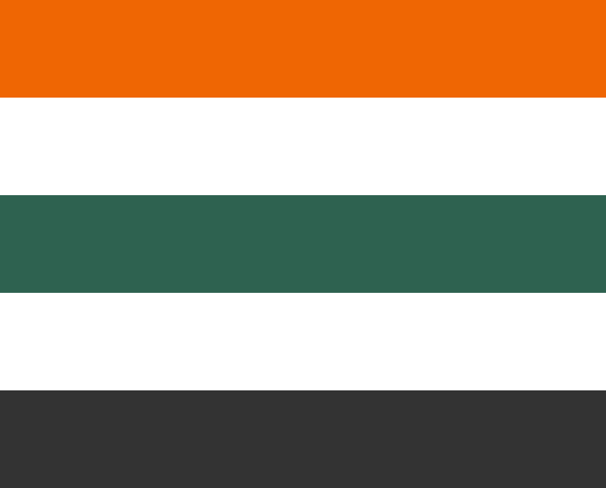

#2F6B54 -- Gable Green

#EF6603 -- Clementine

#333333 -- Mine Shaft

The aforementioned colors make up the Color palette of Gabi Website. The basis of choosing them is from the colors of the uniform with consists of a dominant Gable Green (school blazer; Used on the hero, section separator, nav-pills, top navigation active links and footer), Mine Shaft (school blazer, sweater, skirt and trousers; used on top navigation bar) and Clementine which is not represented in the school's uniform. Clementine was chosen since it’s a color that stick's out when combined with the other two colors hence suitable for elements for call to action as well as alongside lists to make them pop out. Clementine was used in place of #C7A395 -- Eunry, which is a dull color but on our uniform. White was also applied to bring out grouping and isolation of items on the web site to ensure they pop out and blend well with each other to achieve symmetry (horizontal symmetry).

# Layout

Responsive layout has been applied to ensure all screens are accommodated for easier interaction with the site.

Navigation Layout changes from Top Navigation to a column navigation on mobile that occupies the whole screen.

Other elements also adjust their size (fluid) and flow to occupy one column on smaller screens.

The rule of thirds was also applied on the elements accompanied with pictures (Gallery Details and project page) to achieve aesthetic beauty.

Horizontal Symmetry has also been applied throughout the site especially on the homepage with content divided into two columns sitting side by side to achieve balance along the x-axis.

# Texture

Floating Nav Pills on the home page about section, submit button in contact us page and Floating Navigation on Exam Results Page creates an illusion of a 3-dimensional space through use of box-shadow CSS property. The goal is to make it stick out of the page.

On click, inset box-shadow property is applied to (index page top navigation and exam page secondary navigation, submit button in contact us page) make it appear pressed.

The use of a darker shade of Clementine on the social links button (footer) also makes them appear pressed on mouse hover

The application shadow by use of box-shadow promotes volume and depth therefore affecting texture.

Floating wavy hero at the fold of the home page evokes a sense of movement and excitement.